Assignment #13 Watson Analytics Assignment by Joshua Troup

Data Set: WA Sales Products 2012-2014

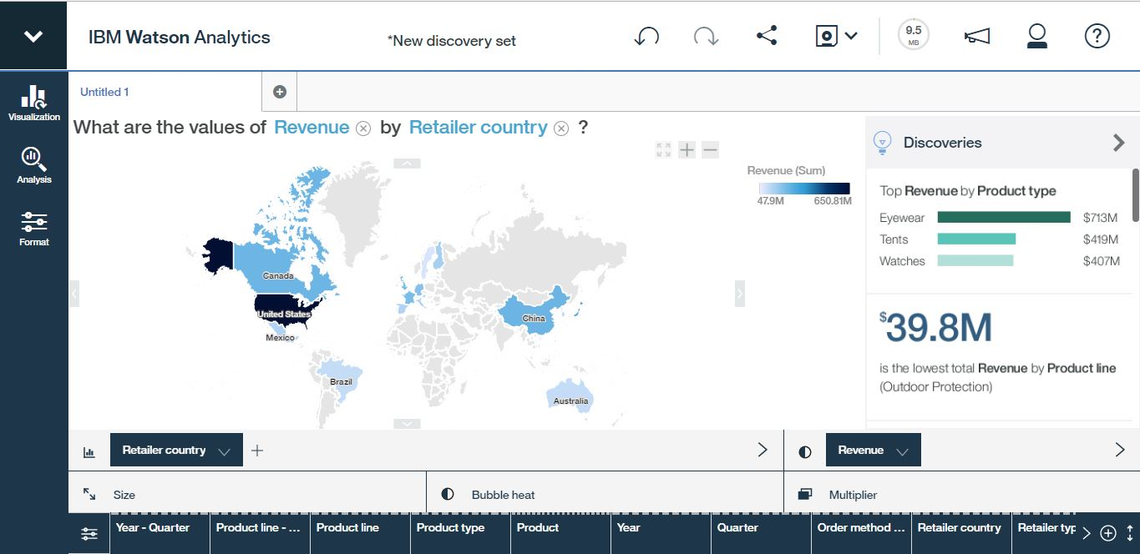

United States is the country with the largest sum of revenue by retailer country with a value of $650,810,960.52. Canada and China are the second largest in the world with China’s value at $248,823,216.53 and Canada’s value at $246,887,664.87. Mexico, Brazil, and Australia have values under $150,000,000.00.

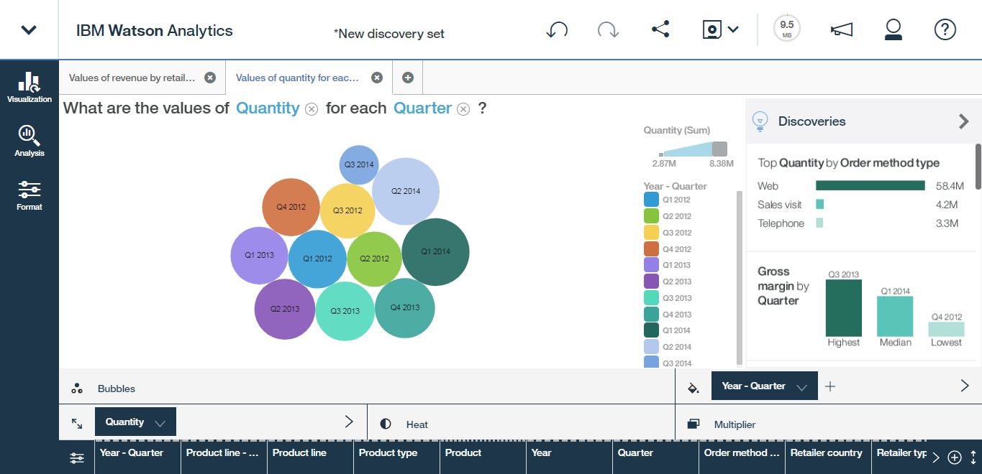

The bubble graph displays the quarters over a three year period shows the quantity for each quarter were significantly close to one another. Quarter 3 in 2014 was the lowest amount with a value of 2868410. Quarter 1 in 2014 was the largest amount with a value of 8382882 with the preferred order method being online (Web). Top quantity by order method type is significantly higher in Web than it is door to door sales and telephone sales.

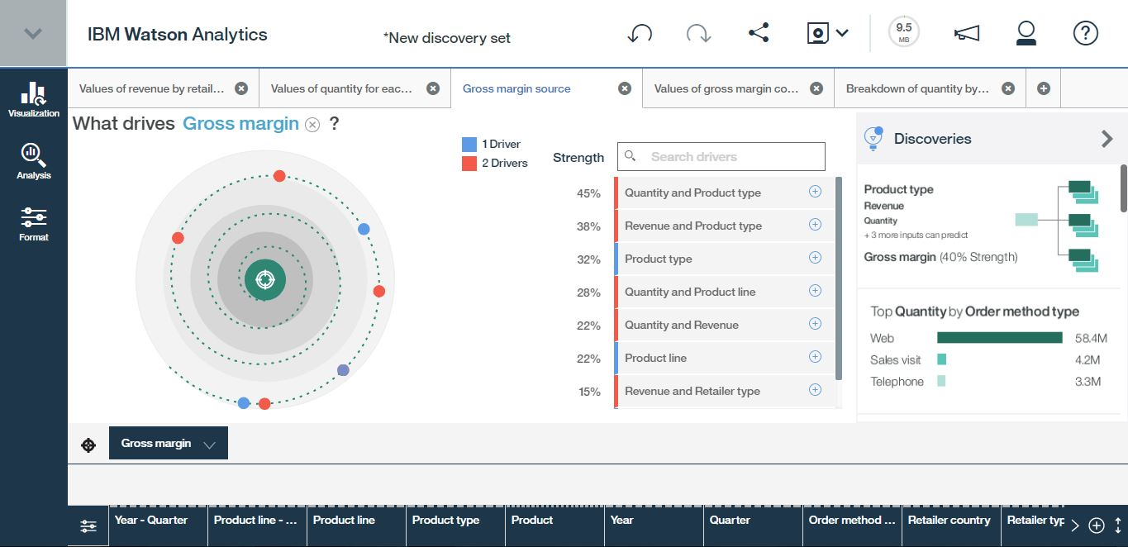

Quantity and product type drive gross margin at a value of 45% with 2 drivers. Revenue is a predictor of gross margin at a value of 13% with 1 driver.

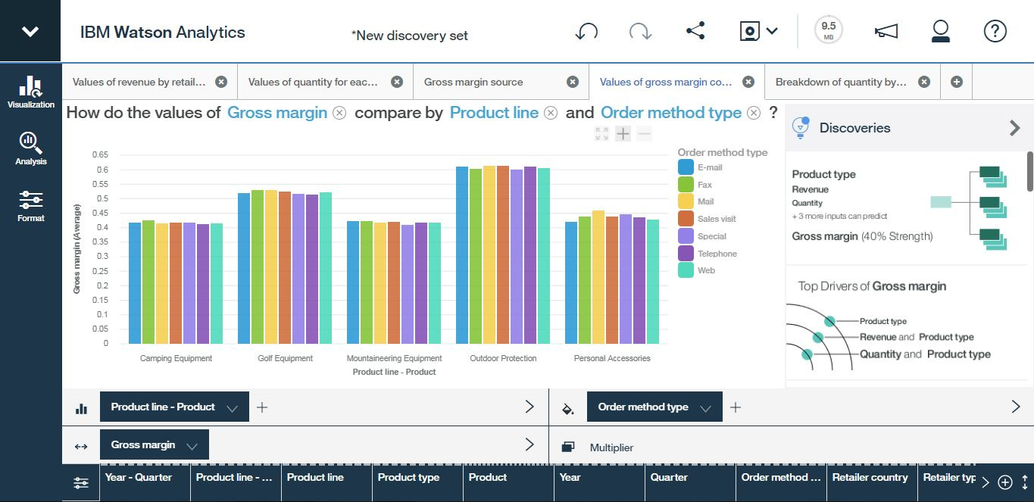

Order method type based on product line and gross margin is not significant as the graphs show product categories with very similar bar lengths. Outdoor protection is the greatest average gross margin between .6 and .65. Camping Mountaineer equipment and personal accessories are the lowest average gross margin between .4 and .46.

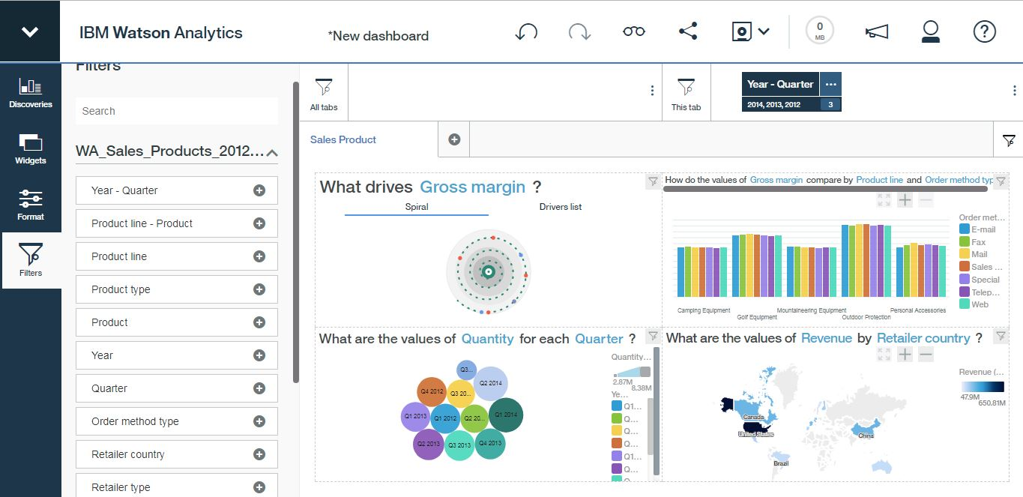

Dashboard view of all 4 graphs clustered together for easy viewing. Year-Quarter filter is present if viewer wants to view certain years-quarters. All 3 years are currently included in the displays.